**SmartTech Solution Pvt. Ltd.**

Thapagaun, New Baneshwor

Kathmandu, Nepal

+977 - 01 - 5245027

**User Manual**

**For**

**Asset Management Web Configuration Panel**

# 

**1. Getting started with the Web Configuration Panel** **2**

1.1 About the Web Configuration Panel 2

1.2 Accessing the Web Configuration Panel 2

**2. Using the Web Configuration Panel** **2**

2.1 Home 2

2.1.1 Add/Edit General Information 3

2.1.2 Add/Edit Mobile App Users 3

2.1.3 Add/ Edit Supply Schedule 4

2.1.4 Add/Edit Beneficiary Information 5

2.1.5 Add/Edit Supply Belts 5

2.1.6 Tariff Rates 6

2.2 Finance 6

2.2.1 Tariff Rates 6

2.2.1.1 Add/Edit Tariff Rates 6

2.2.1.2 Income Estimates -This year & All Time 7

2.2.2 Other Parameters 7

2.2.2.1 Add Inflation (%) Parameters 8

2.2.3 Cash Book 8

2.2.3.1 Manage Income Categories 9

2.2.3.2 Manage Expenditure Categories 9

2.2.3.3 Add/Edit Income 10

2.2.3.4 Add/Edit Expenditure 10

2.3 Maintenance 11

2.3.1 Component Categories 11

2.3.1.1 Add/Edit Component Categories 11

2.3.1.2 Add/ Edit Component 12

2.3.2 Asset Components 12

2.3.2.1 Add/Edit Component Info 12

2.3.2.2 Add/ Edit Components Logs 13

2.4 Service 14

2.4.1 Quality Test Parameter 14

2.4.1.1 Add Quality Test Parameter 14

2.5 Notifications 15

2.5.1 Manage Notifications 15

2.6 Change Language 16

2.7 Logout 16

# 

# 1. Getting started with the Web Configuration Panel

## 1.1 About the Web Configuration Panel

The Web Configuration Panel enables users to add, edit and view general information, mobile app users, tariff rates about the water system. This also helps to configure and update different financial records, maintenance Information, service records, etc. This web utility will guide you through the different tabs and sub-tabs including the notification tab.

## 1.2 Accessing the Web Configuration Panel

You can access the Web Configuration Panel using any compatible browser installed on your PC. To log into the web configuration panel, you will need the authorized Username and Password.

# 2. Using the Web Configuration Panel

When a Water System’s User logs in to the web application, the Configuration Panel is the first screen he/she will see.

## 2.1 Home

In the home tab of the configuration panel, users can add General Information, Beneficiary details, supply belts, Supply Schedule, and Mobile App users of the Water System. Users can also see the tariff rates, based on the User Based and Fixed Based option.

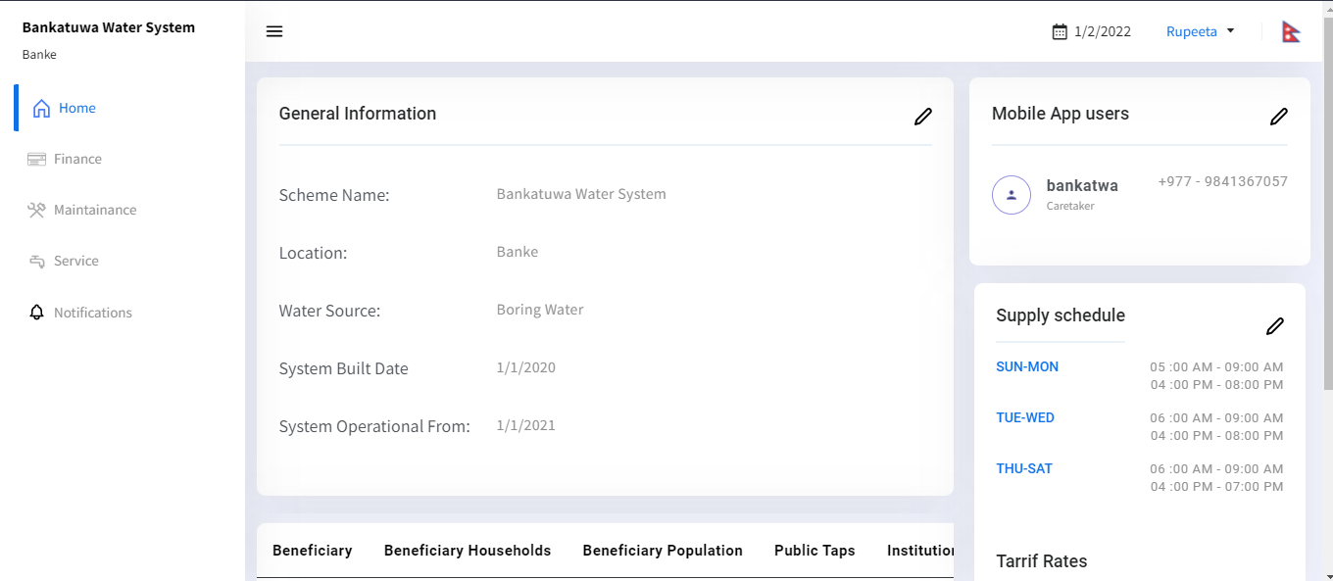

# 

### 2.1.1 Add/Edit General Information

Users can add the General information of the Water Scheme by clicking on the edit icon placed in the right corner of the content.

Then a pop-up form is displayed where the following details have to be filled up:

1. Scheme Name: Add the Name of the Water System
2. Location: Add the location & address of the Water System
3. Water Source: Add source of water e.g. Boring water, Spring water etc
4. System Built Date: Add Water System’s built date
5. System Operational Date : Add date from where the water system operated

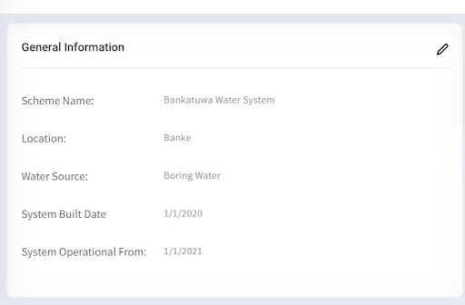

### 2.1.2 Add/Edit Mobile App Users

After adding General information, the User has to click on the Mobile App Users where a pop-up form will be displayed. In order to add the Mobile App Users, the following details have to be filled up:

1. Name: Add the name of the mobile app user
2. Phone: Add phone number of the mobile App User
3. Username: Add username for the mobile app user
4. Password (PIN): Add a password which shouldn’t be less than Four number digits.
5. Confirm Password: Add the same password which was created previously for the confirmation
6. Save the added data by clicking on the Save Button

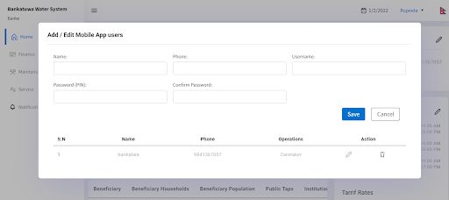

### 2.1.3 Add/ Edit Supply Schedule

In order to add and edit the supply schedule of the water system, the following details have to be filled up:

1. Day: Add the day for the supply schedule ( eg: Sunday, Monday or Sun-Thur, etc)
2. Supply Belt: Supply Belt is not a required field so user can skip this field
3. Morning : Add water supply time for the morning
4. Evening: Add water supply time for the evening
5. Save the added data by clicking on the Save Button

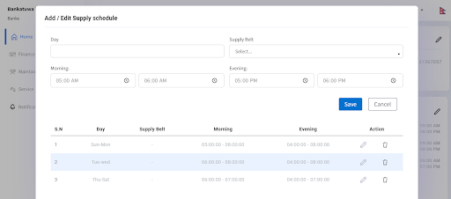

### 

### 2.1.4 Add/Edit Beneficiary Information

In order to add and edit Beneficiary Information of the Water System, the following details have to be filled in:

1. Beneficiary Households: Add the number of the beneficiary households number (eg: 250 Houses)
2. Institutional Connection: Add the number of the institutional connections ( eg: 20 Schools)
3. Apply Date: There will be a by default apply date as per the Water System.
4. Beneficiary Population: Add the total number of the beneficiary population (eg: 3000)
5. Taps: Add the total number of the Public Taps
6. Save the added data by clicking on the Save Button

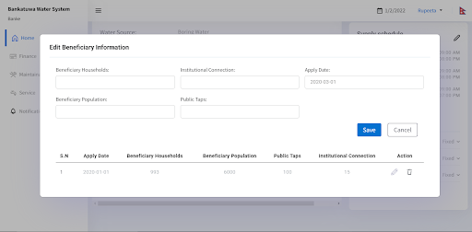

### 2.1.5 Add/Edit Supply Belts

Users can skip this field since there is no need to add Supply Belts for now.

### 

### 2.1.6 Tariff Rates

In the Tariff Rate Section, users can view different tariff rates by clicking on the fixed and user-based rates of Institution & Households for the respective years.

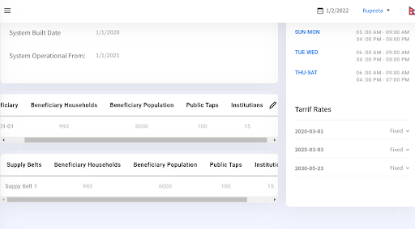

## 2.2 Finance

In the Finance tab, there are mainly three sub-menus. Tariff Rates, Other Parameters and Cash Book. In order to add these, the following details have to be filled:

### 2.2.1 Tariff Rates

#### 2.2.1.1 Add/Edit Tariff Rates

In order to add Fixed Based Tariff Rates, the following details have to be filled:

1. Apply date: There will be a by default apply date as per the Water System.
2. Rate for Households(Rs): Add the water tariff rate for the households connection
3. Rate for institutions(Rs): Add the water tariff rate for the institutional connection
4. Estimated paying connection Households (%): Add the estimated paying connection Households in % (eg: 40%)
5. Estimated paying connection Institution(%): Add the estimated paying connection Institution in % (eg: 60%)
6. Save the added data by clicking on the Save Button

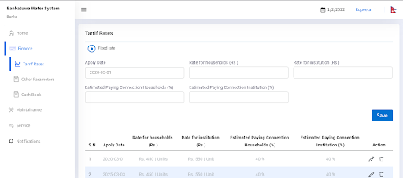

#### 2.2.1.2 Income Estimates -This year & All Time

Users can view the graph and other short information regarding tariff rates in the income estimates for the current year of water systems and also including other years as well.

### 2.2.2 Other Parameters

In order to add Other Parameters, the following details have to be filled:

1. Apply Date: Add the apply date by selecting through the calendar since there won’t be a default apply date added.
2. Heading: Add the expense heading.
3. Yearly Expenditure: Add the yearly expenditure.
4. Category: Select one of the categories, either income or expenditure.
5. Apply for specific date: Add “yes” or “No” for the specific date.
6. One Time Cost: Add “yes” or “No” for the one time cost for the other parameters.

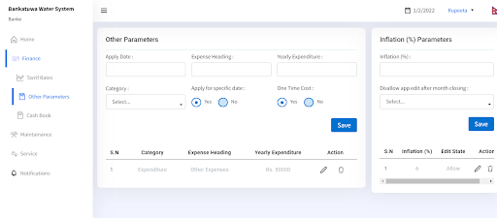

#### 2.2.2.1 Add Inflation (%) Parameters

In order to add inflation parameters, the following details have to be filled: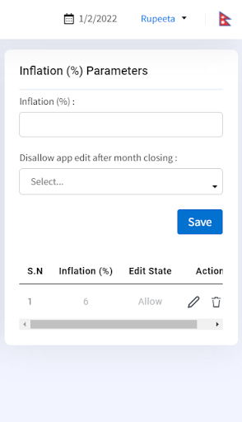

1. Inflation(%) : Add the inflation rate
2. Disallow app edit after month closing: Select Yes or No for the app for month closing after edit
3. Save the added data by clicking on the Save Button

### 

### 2.2.3 Cash Book

In the cash book tab, there are mainly two sections. They are Income and Expenditure. There is also a date filter in the corner of the tab, where the user can select the date as per the date requirement in order to see income and expenses records for the given years.

### 

#### 2.2.3.1 Manage Income Categories

In order to add income categories, the following details have to be filled:

1. Category Name: Add a category name for the Income.
2. Save the added data by clicking on the Save Button.

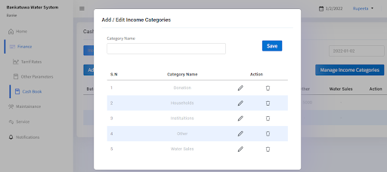

#### 2.2.3.2 Manage Expenditure Categories

In order to add expenditure categories, the following details have to be filled:

1. Category Name: Add a category name for the Expenditure
2. Save the added data by clicking on the Save Button

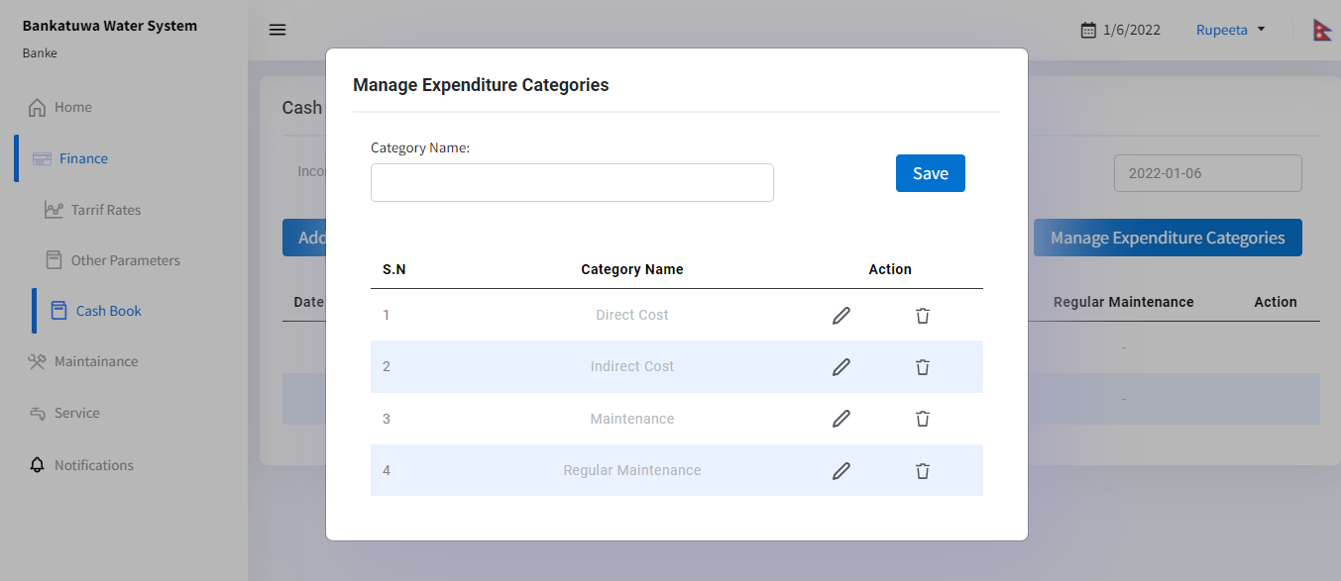

#### 2.2.3.3 Add/Edit Income

In order to add the income, the following details have to be filled:

1. Category: Select category from the given income category lists
2. Date: Since the user would have already selected the date beforehand, there will be a date for the income by default.
3. Title: Add the income title
4. Amount: Add the income amount
5. Water Supplied (Ltrs): Add the total water supplied for the month in Liters
6. Save the added data by clicking on the Save Button

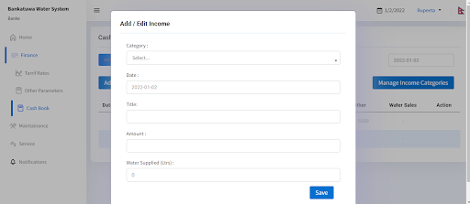

#### 2.2.3.4 Add/Edit Expenditure

In order to add the expenditure, the following details have to be filled:

1. Category: Select category from the given expenditure category lists
2. Date: By default, there will be a date for the expenditure since the date would have already been selected by the user beforehand.
3. Title: Add the expenditure title
4. Amount: Add the income amount
5. Water Supplied (Ltrs): Add the total water supplied for the month in Liters
6. Save the added data by clicking on the Save Button

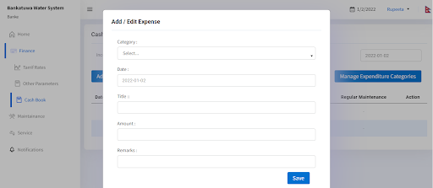

## 2.3 Maintenance

In the Maintenance tab, there are mainly three sub-tabs. They are Component Categories, Asset Components and Components Logs. In order to add the multiple data regarding this, the following details have to be filled:

### 2.3.1 Component Categories

#### 2.3.1.1 Add/Edit Component Categories

In order to add the Component Categories, the following details have to be filled:

1. Title: Add the title of the component category
2. Save the added data by clicking on the Save Button.

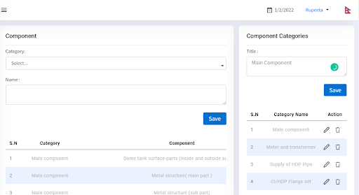

#### 2.3.1.2 Add/ Edit Component

In order to add the component, the following details have to be filled:

1. Category: Select category from the given Component category lists
2. Name: Add the component name
3. Save the added data by clicking on the Save Button.



### 2.3.2 Asset Components

In order to add the information regarding asset components, the following details have to be filled:

#### 2.3.2.1 Add/Edit Component Info

In order to add component info, the following details have to be filled:

1. Component Category: Select the component category from the component lists
2. Component Number: Add the component number
3. Possible failure: Add the possible failure of the component category
4. Maintenance action: Add the maintenance action required for the component category
5. Maintenance Interval: Add the maintenance interval of the component in the year
6. Maintenance cost: Add total maintenance cost without any segregation
7. Labour cost : Add the labour cost (if there is segregation of the cost)
8. Material Cost: Add the material cost (if there is segregation of the cost)
9. Cost: Add the replacement cost (if there is segregation of the cost)
10. Supply Belt: User can skip the supply belt
11. Possibility of Failure: Select one of the possibility of failure from the given list
12. Impact of Failure: Select one of the impact of failure from the given lists
13. Mitigation: Select one of the mitigation from the given lists
14. Designated Person: Select one of the designated persons from the given list
15. Apply Date: There will be a default apply date as per the Water System.
16. Next Action date: There will be a default apply date and if the user wants to change the date,he can add the next action date.
17. Component picture: Add the component picture which should be less than 1Mb
18. Save the added data by clicking on the Save Button.

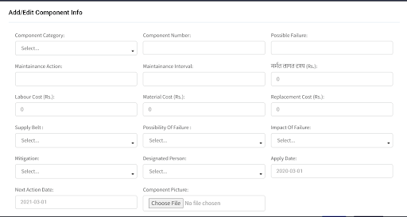

#### 2.3.2.2 Add/ Edit Components Logs

In order to add the component logs, the following details have to be filled:

1. Component: Select the component category from the given listsi
2. Maintenance date: Add the maintenance date for the component category
3. Possible failure: Add the possible failure of the component
4. Duration: Add the duration of the component in order add the log (interval in days)
5. Total Cost: Add the total cost of the component (without any segregation cost)
6. Labor cost: Add the labor cost (if there is segregation of the cost)
7. Material Cost: Add the material cost (if there is segregation of the cost)
8. Replacement Cost: Add the replacement cost (if there is segregation of the cost)
9. Remarks: Add the remarks for the component
10. Component Picture: Add the component picture which should be less than 1Mb
11. Save the added data by clicking on the Save Button.

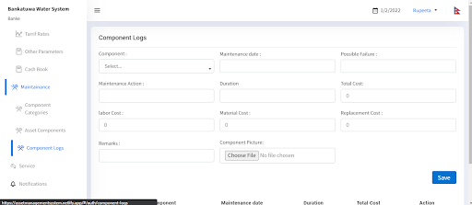

## 2.4 Service

In the service tab, there is only one other sub-tab which is Quality Test Parameters.

### 2.4.1 Quality Test Parameter

#### 2.4.1.1 Add Quality Test Parameter

In order to add the Quality Test Parameter, the following details have to be filled:

1. Parameter: Add the parameter name for the water quality test
2. Unit: Add the unit of the quality test parameter
3. NDWQ Standard: Add the Given NDWQ Standard for the water quality test parameter
4. Types: Select the types, either chemical or other from the lists.
5. Save the added data by clicking on the Save Button.

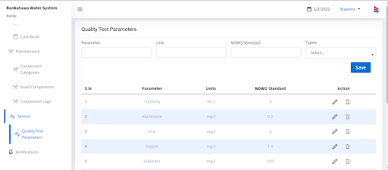

## 2.5 Notifications

In the notification tab, there is a sub-tab named manage notifications.

### 2.5.1 Manage Notifications

In order to manage notifications, the following details have to be filled:

1. Initial date: Add the initial date for the notifications
2. Income notifications period: Add the income notifications period in days
3. Expenditure notifications period: Add the expenditure notifications periods in days.
4. Test result notifications period: Add the test result notifications periods in days.
5. Supply record notifications period: Add the supply record notifications periods in days.
6. Save the added data by clicking on the Save Button.

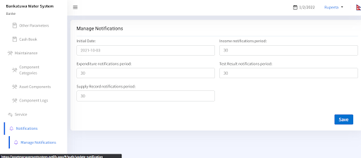

## 2.6 Change Language

There is availability of two languages: English and Nepali in the configuration web utility. Users can select the language by:

1. Clicking on the top right corner where there is an Icon of Flag in the configuration panel.

## 2.7 Logout

Users can logout from the web configuration by:

1. Clicking on the name of the user placed on the right side of the panel near the language selection and clicking on the Logout displayed text.

**Thank you**